How does your community effect North Keppel Island?
Chance – Rubbish.
Rubbish goes across the GBR and comes to NKI.
Nathan – Rubbish, plants, pollution / smoke.
Rubbish is affecting NKI because the animals in the reef could eat it and choke.
Grady – Pollution, water.
Too much rubbish because it kills the animals because they it the rubbish.
Logan – Pollution, plastic and water.
Pollution and littler is effecting NKI because people are too lazy to put rubbish in the bin and the beaches get dirty.
Bobby – The pollution, water and food.
We should pick up rubbish to make the Island live and make more coral.
Tyrell – You can have more fun.
More people are throwing rubbish in the water that will kill animals.
Chevelle – The water and tides, dry land and dogs, electricity.
By Shampoo that has chemicals in it, because it goes into the drain to go to the beach which kills fish.
Taormina – Litter.
They don’t care for the animals.
Cohan – Electricity.
By dumping rubbish in the water kills the reef.
Tyson – Food and rubbish.
Rubbish is making all kind of sea creatures die.
Chad – Rubbish, pollution / smoke.
Coral is an animal!
Dakota – How we behave.
Letting rubbish; plastic bags, bottles and glass go in the oceans and turtles eat them.
Tarlia – It feels different because there is no cars or rubbish.
There is a lot of rubbish from our community and it wrecks all the coral and sea life animals.
Paige – It feels different because there is no cars or rubbish.
Rubbish, it is affecting the GBR and killing the sea animals.
Charlotte – Rubbish, air-conditioning, pollution.
The rubbish / plastic bags is flying everywhere killing turtles and other animals.
Felicity – It is having an effect on North Keppel because there is limited water, food, electricity and there is a lot of water.
Littering at school.
Lukas – Water changes the sea.
What fish formed with coral alive?
Sandy – Plastic pollution, too much electricity use.
To not use so much electricity.
Mia – We don’t go fishing for a good reason.
Saneesa – The rubbish in the water effects animals.
People being lazy, not putting rubbish in the bin and the wind picks it up to the water.
Alex – There is not much water.
Get rid of litter eg plastic.
Danny – Water, litter.
Miley – Littering.
We picked up rubbish so turtles don’t die and so we don’t eat it when we catch fish.
Zeb – Water, food and rubbish.
The people throw their rubbish, effects NKI because turtles could eat it and sea animals will die.
Jusann – The toilet water washes our business to the ocean and lands up on the shore.
By people being lazy to put there rubbish into the bin. By humans chopping down trees and making erosion the ocean rises.
Kai – The amount of water.
Jai – Rubbish.
Water Pollution effects NKI because it kills coral and turtles think its jellyfish
Peter – Rubbish.
People chucking rubbish.
Halen – Rubbish
Too much pollution that people are making.
Ryan – We found a satellite and rubbish on an island can kill the fish.
Bodie – Rubbish on the reef and in the water.
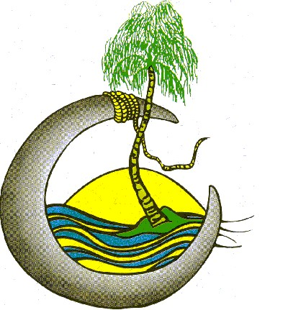
What do you want to know while on North Keppel Island?
Chance – What creatures live on North Keppel Island?
Nathan – How was coral made?
What was coral first made to be?
Grady – How does the rubbish effect the reef?
Is coral a plant or animal?
Ryan – How do bush fires start? Stove cooking.
Halen – What are animals like on North Keppel Island?
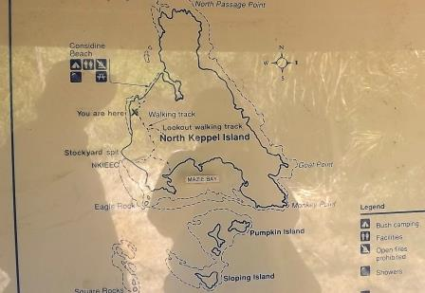
Logan – Why do people pollute?
Bobby – Does coral float?
How to build a raft?
Tyrell – Are corals animal?
How do corals live?
Chevelle – How is the water effecting North Keppel Island?
Would dry land effect North Keppel Island?
Taormina – Why do people not care for the land?
Is litter popular on North Keppel Island?
Cohan – How can I learn to snorkel?
Tyson – Can we raft build?
Chad – Is coral an animal?
Dakota – How many types of sea life is there in the Great Barrier Reef?
Tarlia – Is corral and seaweed an animal?
Paige – Why is pollution so deadly (bad)?
Charlotte – When we go in the water really deep, will something try to hurt or eat us?
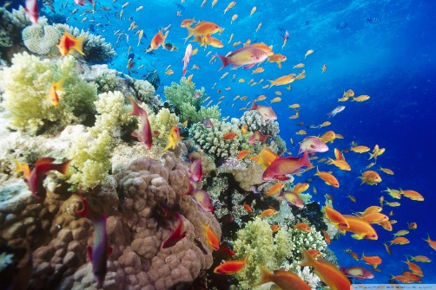
Felicity –Are ________ a mammal or insect?
Lukas – Are shells alive?
Sandy – How can we fix the coral?
How to build a shelter?
Mia – Why do people fish? Is coral alive?
Saneesa – How did they build the cabins and facilities on this Island?
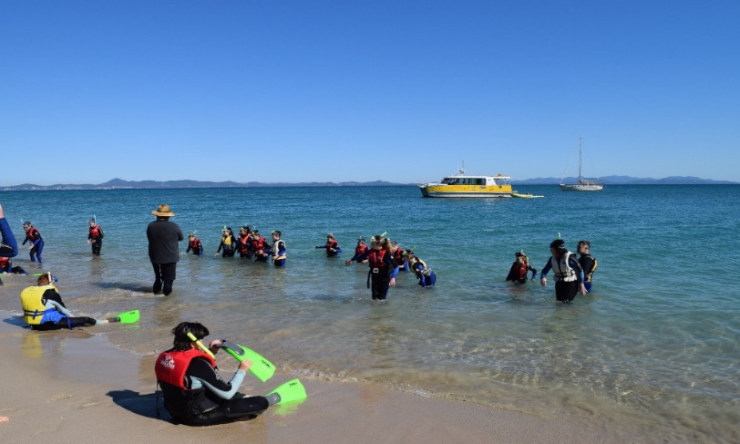
Alex – Why is there a Great Barrier Reef?
Why does the water change colour?
Danny – How do animals get here?
Miley – Why do people not care about littering?
Zeb – Is there fresh water crabs?
Jusann – Is there activates for learning?
Is living on the Island hard?
Kai – What do you do if something is annoying the animals?
Jai – How did you know the name of the island?
Peter – Can fish get killed by plastic?

