How does your community effect North Keppel Island?
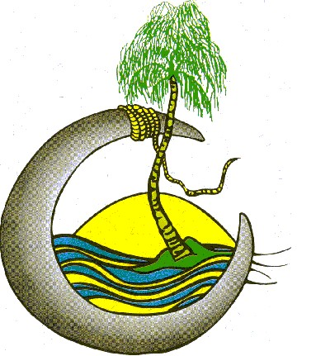
Rachael – Rubbish bags can have an effect and kill turtles. Oil spills can kill a lot of animals.
Molly – Non-native animals. Sewage water coming over to NKI.
Aria – Plastic bags, rubbish and oil spills. Birds eat seeds off the ground and poops on the Island
Raine – All types of rubbish. Rubbish.
Aarnnie – Rubbish in the water can take 500 years to break down. The Rocky River is polluting the Keeples and the coal is dying.
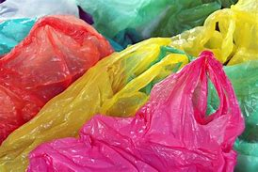
Ella – Litter. Our boats when they leak petrol.
Hayley – Rubbish. Emu Park has an effect on NKI because they are not the same.
Hamish – Plastic rubbish. Litter in the ocean comes to NKI and ruins the reef.
Shannee – Tourists, micro plastics in the water. We use fossil fuels.
Cooper – Rubbish in the water creating pollution. Rubbish thrown in the water makes pollution and damages the reef.
Thor – Rubbish and plastic bags going into the ocean. Rubbish that goes down the drain.
Grace – Bringing over cane toads without knowing. Crown of thorns.
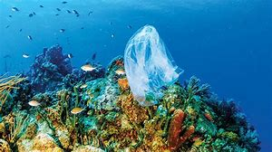
Reagan – Stop hunting. Boats.
Kaylee – Littering, plastics.
Ameliah – Throwing plastic away. Animals from the island spread seeds.
Emily – The rubbish could get blown over by the wind. Soapy water coming over from the Fitzroy River.
Carter – Rubbish in the water, bringing animals to the island. Pollution and global warming.
Harlee – Plastics. We can spread prickles.
Alex – Littering, plastics, using less water and electricity. Using so much water and energy.
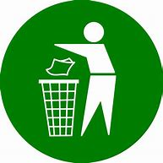
Riley – Visiting too much and wrecking the beach. By dropping rubbish on the beach and it traveling to NKI.
Michael – Killing animals and rubbish. Fishing / hurting marine life.
Jacob – Littering food scraps, killing plants. Rubbish.
Shakira – Rubbish getting thrown into the ocean. Throwing lots of rubbish into the environment.
Noah – Throwing plastic and rubbish. Rubbish thrown in the river and sea, it washes up on NKI.
Mitchell – We bring over introduced species and plants. Too much rubbish and overfishing. We are destroying our coral and coral reef.
Madeline – Help the island. Pick up the rubbish so it does not go into the ocean.
Kodi – Plastic bags and other rubbish. Rubbish being washed out to sea.
Zac – We litter all over the place and don’t look after our wild life. We pollute which makes all the water dirty and kills the reef.
Benji – Brining a prickle in our shoe and spread to the Island. Dropping rubbish on the ground.
Liam – Plastic going into the ocean and turtles eating it. Rubbish going into the water.
Tahlia – Plastic. Bird’s seed.

What do you want to know while on North Keppel Island?
Rachael – When are we going hiking? How long can a stingray live? Can dolphins eat a starfish?
Molly – What was some of the native people names? Did native people have money?
Aria – Does the reef stop changing? How do trees grow on the island?
Aarnnie – Why do we have to wear a stinger suit in the water? Why is plankton so small?
Ella – Why is the water so clear? Why does coral die?
Hayley – do you have to sit down if you feel sick on the boat? Why do you make morning tea and afternoon tea for us?
Hamish – How long has it taken to build all of this on this part of the island? How long has the land been called North Keppel?
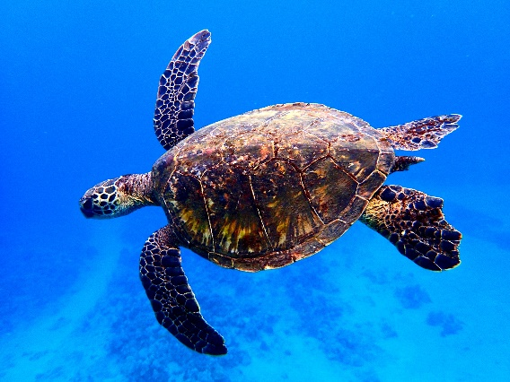
Shannee – Why is North Keppel a national park?
Cooper –When do we scuba dive? Where do you think treasure is?
Thor – Are we going to go on a walk? Why don’t you bring water from the mainland?
Grace –What will happen if we get stung by a jellyfish or stingray? What do you do with manure when we leave?
Reagan – Can we stop hunting for food? How did the aboriginals survive?
Kaylee – What animals are on North Keppel Island?
Ameliah –Why do we have to wear shoes in the water? Why did you make a school?
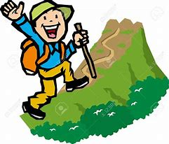
Emily – How long does the reef go for? Is zooplankton the smallest animal in water?
Carter – How big is the island?
Harlee – Can we play cricket? Do turtles lay eggs on North Keppel?
Alex – How does the reef reproduce? How hard is coral?
Riley – Why is the island called North Keppel Island? Why is Great Barrier Reef called Great Barrier Reef?
Michael –How do the animals survive?
Jacob –Will we see a possum?
Shakira – How long did it take to build all the cabins, games and all the other equipment? How many people work here?
Noah – Is it nice living here? How hot can it get here?
Mitchell –How did the Great Barrier Reef start forming? Why did the native people come this way?
Madeline – How long has the island been here? How is the possums here?
Kodi – How many animals die here per year? Why do wear shoes in the water?
Zac – What type of fish swim in the reef? How did the wildlife get here?
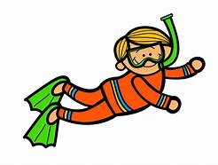
Benji – How do stinger suits help you not get stung? How does plankton make oxygen?
Tahlia – If you could have more animals, would you?

